Time: 25 min
GPT Rate: 7 Bands
The chart below gives information about how families in one country spent their weekly income in 1968 and in 2018.
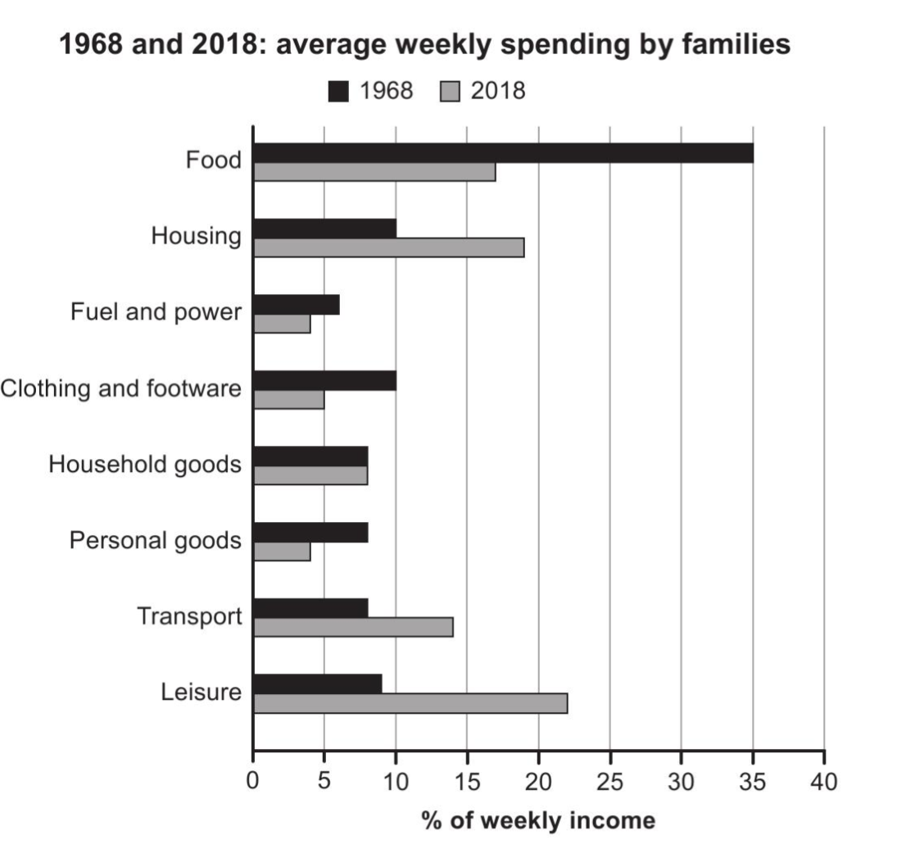
The provided chart illustrates statistical insights into how families in a country spent their weekly income in 1968 and in 2018.
Overall, it is evident that food, housing, and leisure accounted for the largest share of weekly expenditure in both time frames. whereas fuel and power accounted for the smallest share of spending.
An analytical perspective highlights that 35% of weekly income was spent on Food in 1968. In contrast, this trend had a dramatic decrease over the period, and approximately 18% weekly budget was invested in food in 2018. Meanwhile, Fuel and power, personal goods, and clothing and footwear followed the overall decline over the period, housing expenditure increased from 10% to 19%, personal goods dropped from 8% to 4%, and clothing and footwear consequently had a downward trend. Subsequently, families spent about 8% of income on Leisure in 1968. Apparently, this figure more than doubled, reaching over 18% in 2018. Similarly, Housing and Transport followed the increasing trend, while housing expenditures rose from 10% to 19%, weekly expenditure on travel rose from 8% to 14%. At the penultimate stage, Household goods remained constant across both time frames, at about 8%

